servlet

References: http://www.paidmembershipspro.com/2013/04/adding-a-new-payment-gateway-option-to-paid-memberships-pro/

**Integration Click & Pledge Payment Gateway**:

**Requirements:** Paid Memberships Pro requires a minimum of WordPress version 3.0+ in order to function properly.

1. **Make sure that Paid Memberships Pro plugin installed and enabled (http://downloads.wordpress.org/plugin/paid-memberships-pro.zip)**
2. Make sure to dump all the downloaded files from the above link to your WordPress project plugins.

<your host root>\wp-content\plugins\

**Integration of Click & Pledge:**

Copy all files downloaded from github to following locations (Please follow the folder structure in the downloaded files)

File ‘**adminpages.php**’ to (This will replace the ‘adminpages.php’ file)

<your host root>\wp-content\plugins\paid-memberships-pro\adminpages

File ‘**class.pmprogateway_cnp.php**’ to

<your host root>\wp-content\plugins\paid-memberships-pro\classes\gateways

Files ‘**Countries.xml**’, ‘**US_States.xml**’ to

<your host root>\wp-content\plugins\paid-memberships-pro\classes\gateways\ paid-memberships-pro\includes\lib\CnP\

**Note:** You need to create folder ‘CnP’ in

<your host root>\wp-content\plugins\paid-memberships-pro\classes\gateways\ paid-memberships-pro\includes\lib

**Admin login**:

**http://<your_wordpress_home>/wp-login.php**

**to log into WordPress admin area.**

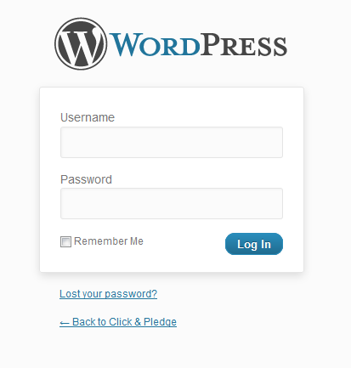

After login into admin area

Then go to ‘plugins->Installed Plugins’ enable the ‘**Paid Memberships Pro’**



1. Setup your settings by clicking on ‘Memberships’
2. Click on ‘Memberships->Payment Settings’ to setup payment gateway
3. Select ‘Click & Pledge’ from above screen in ‘Payment Gateway´option, then enter ‘Account ID’ and ‘API Account GUID’

**Tax Settings**:

If you want to use Tax settings for US & Non-US states, you need to enable the Click & Pledge Tax settings plugin

1. Make sure that copy ‘pmp-tax’ folder from downloaded files to

<your host root>\wp-content\plugins\

1. Then go to ‘plugins->Installed Plugins’ enable the ‘**PMPro Customizations’ plugin**



1. Then you can find tax related on the Payment settings page when you select ‘Click & Pledge’ as ‘Payment Gateway’

Member Ships -> Payment Settings -> Payment Gateway

Select ‘Click & Pledge’ from dropdown list provided at ‘Payment Gateway’

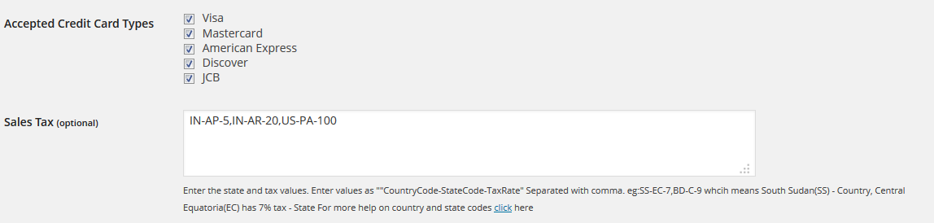

Enter the state and tax values. Enter values as ""CountryCode-StateCode-TaxRate" Separated with comma.

You need to provide the values as following eg

IN-AP-10

This means

India (IN) – Country

Andhra Pradesh (AP) – State

Has tax 10%